**Champernowne Constant (C10)**

Champernowne Constant is a real number whose decimal digits are obtained by concatenating the decimal expansions of the successive positive integers:

*C*10 = 0.12345678910111213141516…

It is named after economist and mathematician David G. Champernowne, who published it as an undergraduate in 1933.

The Champernowne constants can be expressed exactly as infinite series:

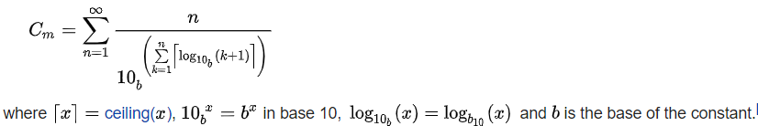

The continued fraction expansion (CFE) of the Champernowne constant turns out to be a set large numbers with various spikes. [Kurt Mahler](https://en.wikipedia.org/wiki/Kurt_Mahler) showed that the constant is [transcendental](https://en.wikipedia.org/wiki/Transcendental_number);therefore, its continued fraction does not terminate and is aperiodic (because it is not an irreducible quadratic). The terms in the continued fraction expansion exhibit very erratic behaviour, with extremely large terms appearing between many small ones. The CFE begins with 0; 8, 9, 1, 149083, 1, 1, 1, 4, 1, 1, 1, 3, 4, 1, 1, 1, 15, and the coefficient in position 18 has 166 digits. The large number at position 18 has 166 digits, and the next very large number at position 40 of the continued fraction has 2504 digits. The fact that there are such large numbers as terms of the continued fraction expansion is equivalent to saying that the convergents obtained by stopping before these large numbers provide an exceptionally good approximation of the Champernowne constant.

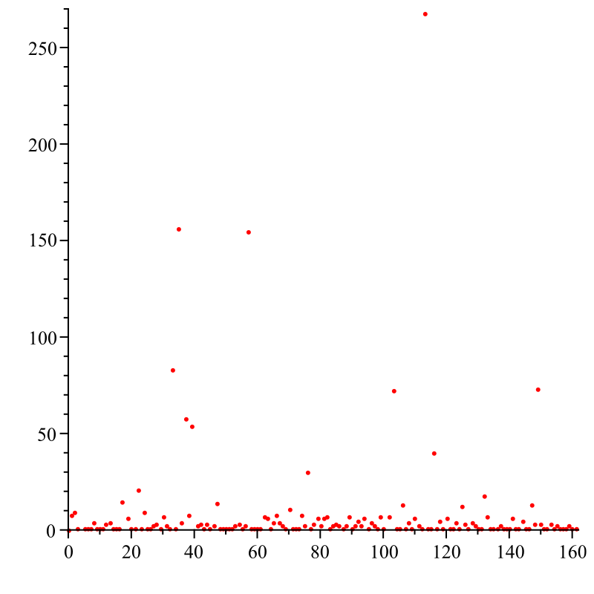

Fig. The first 161 quotients of the Champernowne constant.